***Chemistry***

**13: Fundamental Equilibrium Concepts**

**13.4: Equilibrium Calculations**

51. A reaction is represented by this equation:

(a) Write the mathematical expression for the equilibrium constant.

(b) Using concentrations ≤ 1 *M*, make up two sets of concentrations that describe a mixture of A, B, and C at equilibrium.

Solution

. There are many different sets of equilibrium concentrations; two are [A] = 0.1 *M*, [B] = 0.1 *M*, [C] = 1 *M*; and [A] = 0.01, [B] = 0.250, [C] = 0.791.

53. What is the value of the equilibrium constant at 500 °C for the formation of NH3 according to the following equation?



An equilibrium mixture of NH3(*g*), H2(*g*), and N2(*g*) at 500 °C was found to contain 1.35 *M* H2, 1.15 *M* N2, and 4.12  10–1*M* NH3.

Solution

The reaction may be written as



The equilibrium constant for the reaction is



= 0.0600 = 6.00  10–2

55. A 0.72-mol sample of PCl5 is put into a 1.00-L vessel and heated. At equilibrium, the vessel contains 0.40 mol of PCl3(*g*) and 0.40 mol of Cl2(*g*). Calculate the value of the equilibrium constant for the decomposition of PCl5 to PCl3 and Cl2 at this temperature.

Solution

The decomposition of PCl5 to PCl3 and Cl2 is given as



Let *x* = change in [PCl5].

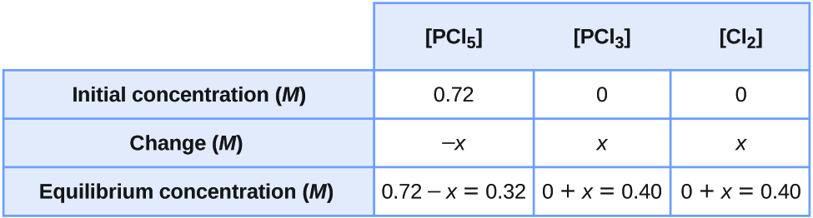



57. Calculate the value of the equilibrium constant *KP* for the reaction  from these equilibrium pressures: NO, 0.050 atm; Cl2, 0.30 atm; NOCl, 1.2 atm.

Solution



59. A sample of ammonium chloride was heated in a closed container. 

At equilibrium, the pressure of NH3(*g*) was found to be 1.75 atm. What is the value of the equilibrium constant *KP* for the decomposition at this temperature?

Solution

Because the decomposition must generate the same pressure of HCl as NH3, 1.75 atm of HCl must be present. 

61. Complete the changes in concentrations (or pressure, if requested) for each of the following reactions.

(a)



(b)



(c) Change in pressure:



(d) Change in pressure:



(e)



(f) change in pressure:



Solution

(a) –2*x*, 2*x*, –0.250 *M*, 0.250 *M*; (b) 4*x*, –2*x*, –6*x*, 0.32 *M*, –0.16 *M*, –0.48 *M*; (c) –2*x*, 3*x*, –50 torr, 75 torr; (d) *x*, – *x*, –3*x*, 5 atm, –5 atm, –15 atm; (e) *x*, 1.03  10–4*M*; (f)*x*, 0.1 atm.

63. Why are there no changes specified for Ni in Exercise 61, part (f)? What property of Ni does change?

Solution

Activities of pure crystalline solids equal 1 and are constant; however, the mass of Ni does change.

65. Analysis of the gases in a sealed reaction vessel containing NH3, N2, and H2 at equilibrium at 400°C established the concentration of N2 to be 1.2 *M* and the concentration of H2 to be 0.24 *M*.



Calculate the equilibrium molar concentration of NH3.

Solution

Write the equilibrium constant expression and solve for [NH3].



[NH3]2 = 1.2  (0.24)3  0.50 = 0.0083

[NH3] = 9.1  10–2 *M*

67. What is the pressure of BrCl in an equilibrium mixture of Cl2, Br2, and BrCl if the pressure of Cl2 in the mixture is 0.115 atm and the pressure of Br2 in the mixture is 0.450 atm?



Solution

Write the equilibrium constant expression and solve for *P*BrCl.



*P*BrCl = 4.9  10–2atm

69. Cobalt metal can be prepared by reducing cobalt(II) oxide with carbon monoxide.



What concentration of CO remains in an equilibrium mixture with [CO2] = 0.100 *M*?

Solution

Write the equilibrium constant expression and solve for [CO].



71. Sodium sulfate 10–hydrate, Na2SO4•10H2O, dehydrates according to the equation



What is the pressure of water vapor at equilibrium with a mixture of Na2SO4•10H2O and NaSO4?

Solution

Because two of the substances involved in the equilibrium are solids, their activities are 1, and their pressures are constant and do not appear in the equilibrium expression.



73. A student solved the following problem and found the equilibrium concentrations to be [SO2] = 0.590 *M*, [O2] = 0.0450 *M*, and [SO3] = 0.260 *M*. How could this student check the work without reworking the problem? The problem was: For the following reaction at 600 °C:



What are the equilibrium concentrations of all species in a mixture that was prepared with [SO3] = 0.500 *M*, [SO2] = 0 *M*, and [O2] = 0.350 *M*?

Solution

Calculate *Q* based on the calculated concentrations and see if it is equal to *Kc*. Because *Q* does equal 4.32, the system must be at equilibrium.

75. Assume that the change in concentration of N2O4 is small enough to be neglected in the following problem.

(a) Calculate the equilibrium concentration of both species in 1.00 L of a solution prepared from 0.129 mol of N2O4 with chloroform as the solvent.

 in chloroform

(b) Show that the change is small enough to be neglected.

Solution

(a) Write the starting conditions, change, and equilibrium constant in tabular form.

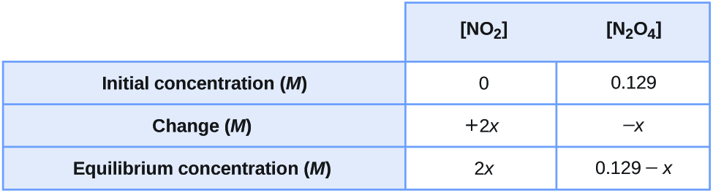

Since *K* is very small, ignore *x* in comparison with 0.129 *M*. The equilibrium expression is



*x* = 5.87  10–4

The concentrations are:

[NO2] = 2*x* = 5.87  10–4 = 1.17  10–3 *M*

[N2O4] = 0.129 – *x* = 0.129 – 5.87  10–4 = 0.128 *M*

(b) Percent error = . The change in concentration of N2O4 is far less than the 5% maximum allowed.

77. Assume that the change in pressure of H2S is small enough to be neglected in the following problem.

(a) Calculate the equilibrium pressures of all species in an equilibrium mixture that results from the decomposition of H2S with an initial pressure of 0.824 atm.



(b) Show that the change is small enough to be neglected.

Solution

(a) Write the balanced equation, and then set up a table with initial pressures and the changed pressures using *x* as the change in pressure. The simplest way to find the coefficients for the *x* values is to use the coefficient in the balanced equation.

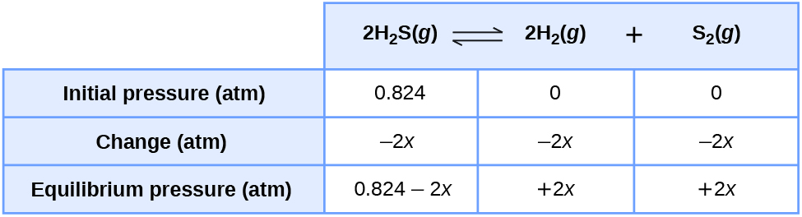



Since the value of *K*p is much smaller than 0.824, the 2*x* term in 0.824 – 2*x* is deemed negligible and, therefore, can be dropped.



1.494  10–6 = 4*x*3

3.73  10–7 = *x*3

7.20  10–3 = *x*

Final equilibrium pressures:

[H2S] = 0.824 – 2*x* = 0.824 – 2(7.20  10–3) = 0.824 – 0.0144 = 0.810 atm

[H2] = 2*x* = 2(7.2  10–3) = 0.014 atm

[S2] = [*x*] = 0.0072 atm

(b) The 2*x* is dropped from the equilibrium calculation because 0.014 is negligible when subtracted from 0.824. The percent error associated with ignoring 2*x* is , which is less than allowed by the “5% test.” The error is, indeed, negligible.

79. What are the concentrations of PCl5, PCl3, and Cl2 in an equilibrium mixture produced by the decomposition of a sample of pure PCl5 with [PCl5] = 2.00 *M*?



Solution

As all species are gases and are in *M* concentration units, a simple *Kc* equilibrium can be solved using the balanced equation:

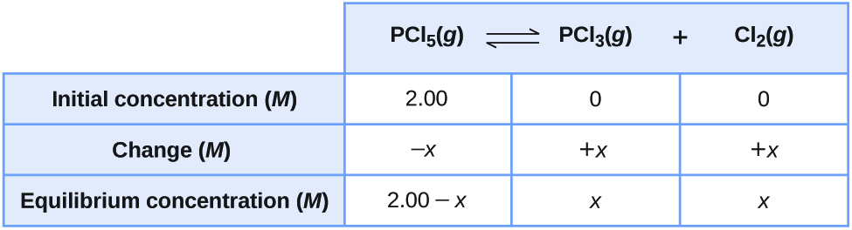



As the value of *Kc* is substantial when compared with 2.00 *M*, the *x* terms in 2.00 – *x* cannot be disregarded. Thus, *x* must be solved by using the quadratic formula.



Begin by arranging the terms in the form of the quadratic equation:

*ax*2 + *bx* + *c* = 0

*x*2 + 0.0211*x* – 0.0422 = 0

Next, solve for *x* using the quadratic formula.





= 0.195 *M* or –0.216 *M*

The process of dissociation renders only positive quantities. Thus, *x* must be a positive value when factored into the solution so as to guarantee a realistic result. The final equilibrium concentrations are: [PCl5] = 2.00 – *x* = 2.00 – 0.195 = 1.80 *M*; [Cl2] = *x* = 0.195 *M*; [PCl3] = [Cl2] = *x* = 0.195 *M*.

81. Calculate the equilibrium concentrations of NO, O2, and NO2 in a mixture at 250°C that results from the reaction of 0.20 *M* NO and 0.10 *M* O2. (Hint: *K* is large; assume the reaction goes to completion then comes back to equilibrium.)



Solution

The equilibrium constant for the reaction is large, so the equilibrium will be closer to all products than all reactants. To start closer to equilibrium, assume all the O2 reacts and “shift” the reactants to products

[O2] = 0.10 *M* – 0.10 *M* = 0 *M*





Using these “shifted” values with *x* the concentration of O2 produced, the ICE table is:

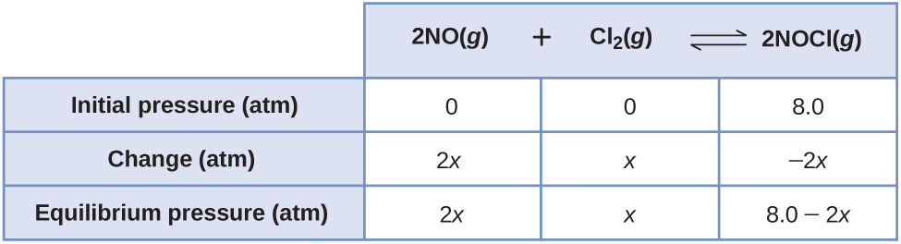



If *x* is small (0.20 – 2*x*) ≈ 0.20, and





Final equilibrium concentrations are:

[NO2] = 0.20 – 2*x* = 0.20 – 2(0.0035) = 0.19 *M*

[NO] = 2*x* = 2(0.0035) = 0.0070 *M*

[O2] = *x* = 0.0035 *M*

The assumption that 2*x<<*0.20is valid because



which is less than the maximum 5% allowed.

83. One of the important reactions in the formation of smog is represented by the equation



What is the pressure of O3 remaining after a mixture of O3 with a pressure of 1.2  10–8atm and NO with a pressure of 1.2  10–8atm comes to equilibrium? (Hint: *KP* is large; assume the reaction goes to completion then comes back to equilibrium.)

Solution

Assume that the reaction goes to completion, where one or both reactants are completely used up:

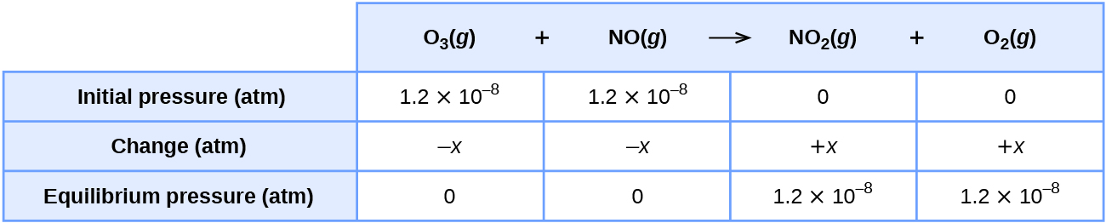

Now assume the equilibrium will be established by the reaction moving toward the reactants:

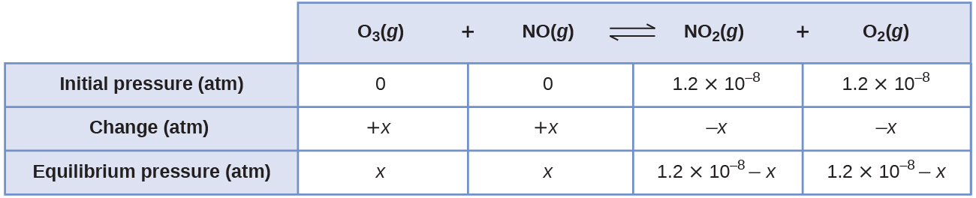



As *KP* is much larger than 1.2  10–8, the X terms in the expression 1.2  10–8 – *x* are relatively negligible and, therefore, can be dropped.



*x* = 4.9  10–26 atm



Clearly *x* is much smaller than 1.2  10–4 so the assumption is valid.

85. Calculate the number of grams of HI that are at equilibrium with 1.25 mol of H2 and 63.5 g of iodine at 448 °C.



Solution

The number of moles of I2 is



The unit for each concentration term is moles per liter. If the volume were known for this exercise, the number of moles in each term should be divided by this volume. However, there are two terms in the numerator and two terms in the denominator, so these volumes cancel one another. Consequently, for any expression with the same number of numerator terms as denominator terms, the number for moles can be used in place of moles per liter. In this exercise, the volume is not needed even though it is given.

(mol HI)2 = *K*  mol H2  mol I2

= 50.2  1.25 mol  0.250 mol

= 15.7 mol2

mol HI = 

Mass(HI) = 3.96 mol  127.9124 g/mol = 507 g

87. What is the minimum mass of CaCO3 required to establish equilibrium at a certain temperature in a 6.50-L container if the equilibrium constant (*Kc*) is 0.050 for the decomposition reaction of CaCO3 at that temperature?



Solution

At equilibrium the concentration of CO2 = *Kc* = 0.50 *M*. The number of moles CO2 in the system is then mol CO2 = 6.5 L  0.50 mol/L = 3.3 mol. The minimum moles of CaCO2 required is then just more than:





89. At 25 °C and at 1 atm, the partial pressures in an equilibrium mixture of N2O4 and NO2 are = 0.70 atm and  = 0.30 atm.

(a) Predict how the pressures of NO2 and N2O4 will change if the total pressure increases to 9.0 atm. Will they increase, decrease, or remain the same?

(b) Calculate the partial pressures of NO2 and N2O4 when they are at equilibrium at 9.0 atm and 25°C.

Solution

(a) The reaction is . At equilibrium, . The value of *KP* must remain the same when the pressure increases to 9.0 atm. Both gases must increase in pressure. (b) . At equilibrium, . For a total pressure of 9.0 atm, the pressure of N2O4 is 9.0 − *x*; that of NO is *x.*

**

7.78*x*2 + *x* – 9.0 = 0

Use the quadratic expression, where





For the plus sign (the negative sign gives a negative pressure which is impossible)



The other answer is extraneous. The pressures are  = 8.0 atm and = 1.0 atm

91. The equilibrium constant (*Kc*) for this reaction is 5.0 at a given temperature.



(a) On analysis, an equilibrium mixture of the substances present at the given temperature was found to contain 0.20 mol of CO, 0.30 mol of water vapor, and 0.90 mol of H2 in a liter. How many moles of CO2 were there in the equilibrium mixture?

(b) Maintaining the same temperature, additional H2 was added to the system, and some water vapor was removed by drying. A new equilibrium mixture was thereby established containing 0.40 mol of CO, 0.30 mol of water vapor, and 1.2 mol of H2 in a liter. How many moles of CO2 were in the new equilibrium mixture? Compare this with the quantity in part (a), and discuss whether the second value is reasonable. Explain how it is possible for the water vapor concentration to be the same in the two equilibrium solutions even though some vapor was removed before the second equilibrium was established.

Solution

(a) For this reaction, . The concentrations at equilibrium are 0.20*M* CO, 0.30 *M* H2O, and 0.90 *M* H2. Substitution gives ; ; Amount of CO2 = 0.33 mol  1 = 0.33 mol.

(b) At the particular temperature of reaction, *Kc* remains constant at 5.0. The new concentrations are 0.40 *M* CO, 0.30 *M* H2O, and 1.2 *M* H2.





Amount of CO2 = 0.50 mol  1 = 0.50 mol. Added H2 forms some water to compensate for the removal of water vapor and as a result of a shift to the left after H2 is added.

93. Consider the reaction between H2 and O2 at 1000 K



If 0.500 atm of H2 and 0.500 atm of O2 are allowed to come to equilibrium at this temperature, what are the partial pressures of the components?

Solution

With such a large equilibrium constant it should be possible to approximate the solutions by starting with as much product (water) as possible. Note this is also a limiting reactant problem, with H2 the limiting reactant. If all 0.500 atm of the hydrogen reacts







Setting up an ICE table with these amounts of reactants and products and using x for the equilibrium pressure of O2 gives these results.

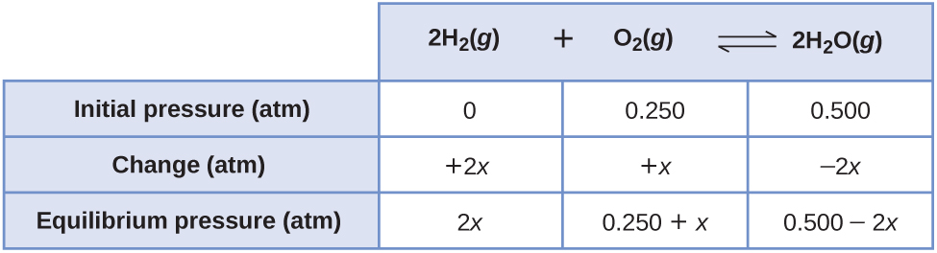

If *x* is small compared to 0.250 (and 2*x* small compared to 0.500), then





*x* = 4.34  10–11

For this case, *x* is indeed small compared to 0.250



so the assumption is valid and the pressures at equilibrium are







95. Consider the equilibrium



(a) What is the expression for the equilibrium constant (*Kc*) of the reaction?

(b) How must the concentration of NH3 change to reach equilibrium if the reaction quotient is less than the equilibrium constant?

(c) If the reaction were at equilibrium, how would a decrease in pressure (from an increase in the volume of the reaction vessel) affect the pressure of NO2?

(d) If the change in the pressure of NO2 is 28 torr as a mixture of the four gases reaches equilibrium, how much will the pressure of O2 change?

Solution

(a) . (b) Because [NH3] is in the numerator of *Kc*, [NH3] must increase for *Qc* to reach *Kc*.(c) That decrease in pressure would decrease [NO2] because the NO2 must convert to NH3 to reduce the effects of the expansion and the consequent relative decrease in products.(d) The relative pressures are controlled by the stoichiometry of the reaction.



97. The hydrolysis of the sugar sucrose to the sugars glucose and fructose follows a first-order rate equation for the disappearance of sucrose.



Rate = *k*[C12H22O11]

In neutral solution, *k* = 2.1  10–11/sat 27 °C. (As indicated by the rate constant, this is a very slow reaction. In the human body, the rate of this reaction is sped up by a type of catalyst called an enzyme.) (*Note:* That is not a mistake in the equation—the products of the reaction, glucose and fructose, have the same molecular formulas, C6H12O6, but differ in the arrangement of the atoms in their molecules). The equilibrium constant for the reaction is 1.36  105 at 27 °C. What are the concentrations of glucose, fructose, and sucrose after a 0.150 *M* aqueous solution of sucrose has reached equilibrium? Remember that the activity of a solvent (the effective concentration) is 1.

Solution

The solvent, H2O, does not enter the equation for *Kc*. The large size of *Kc* indicates that essentially all of the sucrose is in the form of products. If all 0.150 *M* sucrose reacts, the “shifted” concentrations are:

[sucrose] = 0.150 *M* – 0.150 *M* = 0 *M*





Using these “shifted” concentrations the ICE table is:

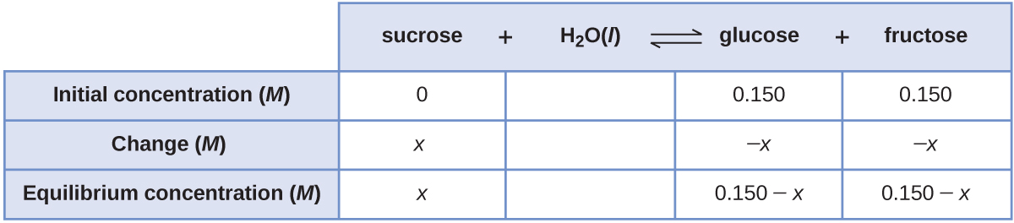



The equilibrium constant is large, if (0.150 – *x*) ≈ 0.150 *M*, then





The concentrations at equilibrium are then

[sucrose] = *x* = 1.65  10–7*M*

[glucose] = [fructose] = 0.150 – *x* = 0.150 *M*

The assumption is valid because



is less than the 5% maximum.

99. Liquid N2O3 is dark blue at low temperatures, but the color fades and becomes greenish at higher temperatures as the compound decomposes to NO and NO2. At 25 °C, a value of *KP* = 1.91 has been established for this decomposition. If 0.236 moles of N2O3 are placed in a 1.52-L vessel at 25 °C, calculate the equilibrium partial pressures of N2O3(*g*), NO2(*g*), and NO(*g*).

Solution

Write the balanced equilibrium expression. With all of the species as gases, it is a straightforward *KP* problem to solve. However, *all* species must be converted to pressures, from other units related to concentration. For N2O3, with 0.236 mol in 1.52 L at 25 ºC:

*PV* = *nRT*



Write the balanced equation and the equilibrium changes:

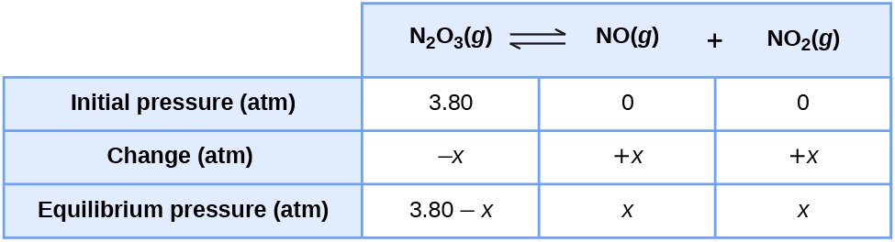





Because 3.80 is substantial when compared with the equilibrium constant, the value of X must be considered. A quadratic equation must be solved:



7.258 – 1.91*x* = *x*2

0 = *x*2 +1.91*x* – 7.258

0 = *ax*2 + *bx* + *c*



= 1.90 atm or –3.81 atm

As negative pressure is not possible in this case, we use the positive value only. The final pressures are:  = 3.80 – *x* = 3.80 – 1.90 = 1.90 atm and .

101. A 0.010 *M* solution of the weak acid HA has an osmotic pressure (see chapter on solutions and colloids) of 0.293 atm at 25 °C. A 0.010*M* solution of the weak acid HB has an osmotic pressure of 0.345 atm under the same conditions.

(a) Which acid has the larger equilibrium constant for ionization

HA  or HB ?

(b) What are the equilibrium constants for the ionization of these acids?

(Hint: Remember that each solution contains three dissolved species: the weak acid (HA or HB), the conjugate base (A– or B–),and the hydrogen ion (H+). Remember that osmotic pressure (like all colligative properties) is related to the total number of solute particles. Specifically for osmotic pressure, those concentrations are described by molarities.)

Solution

(a) Recall that osmotic pressure is a *colligative* property, depending on the total number of particles present in the system. The osmotic pressure equation is *π* = *iMRT*. Given that the two acids face identical reaction conditions, the osmotic pressure (*π*) will increase only with a corresponding (>1) in the degree of ionization (*i*). Because both acids produce two ions per molecule dissociated, the number of particles in solution depends on the size of their respective equilibrium constants (*Kc*(HA) and *Kc*(HB)):



Because HB has a greater osmotic pressure (0.345 atm) than HA (0.293 atm), HB must produce more particles. Therefore, HB ionizes to a greater degree and has the larger *Kc*.

(b) Determine the value of *i* for each acid. For HA,



*i*HY = 1.2

For HB,



*i*HZ = 1.4

The *i* values mean that for every mole of originally undissociated species, *i* moles particles are produced in solution. The dissociations can be expressed in tabular form. For HA,

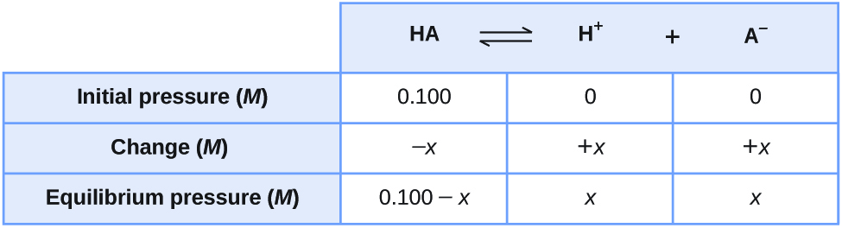

0.012 *M* = *xM* + *xM* + (0.010 – *x*) *M*

*x* = 0.002 *M*

For HB, the only difference from the table for HA is the value of *i*HB. *x* = 0.004 *M*.

Now calculate the values of *Kc*(HA) and *Kc*(HB).

For HA,



For HB,



This resource file is copyright 2015, Rice University. All Rights Reserved.